Little Angels Nursery

Merthrinfa Angylion Bach

Standards &
Quality of Care Report

2019/2020

Date: January 2020
Krishan Kawol

Contents

Purpose of Report 3
Executive Summary 3
Little Angels Nursery: Background 4
Our Staff Team 4
Achievements and Successes 5
OUR CHILDREN 6
Wellbeing, Care and Development 6
Children’s Development and Planning 9
PRACTITIONERS 10
Quality of Staffing 10
Views of Staff 11
THE ENVIRONMENT 15
LEADERSHIP 17
VIEWS OF PARENTS AND CARERS 19
References 31
Appendix A 31
Appendix B 36

Figures

Figure 1 – Our new playroom – The Poppy room 5
Figure 2 – Our New Office and Sleep Room 11
Figure 4 – A sample of our new equipment. Comfy sensory corner for our toddlers and small world dolls house for our preschoolers 17
Figure 5 - My child is happy being at this setting? 19
Figure 6 - Were staff inviting and helpful on your first visit? 20
Figure 7 - Did you settle your child, to suit you? 20
Figure 8 - My child and I feel welcome in the nursery 20
Figure 9 - My child enjoys being at nursery 21
Figure 10 - I am happy with the quality of care my child receives 21
Figure 11 - The learning experiences my child has at the setting are at the right level for them. 21
Figure 12 - My child's learning and development is well supported by the staff in the settling. 22
Figure 13 - Outdoor play areas are clean, safe and well equipped 22
Figure 14 - The setting supports my child’s emotional wellbeing. 22
Figure 15 - My child is making good progress at the setting. 23
Figure 16 - I receive helpful, regular feedback about my child’s learning and development. 23
Figure 17 - Information I receive about my child’s learning and developing is shared with me. 23
Figure 18 - I understand how the setting monitors my child's progress in learning. 24
Figure 19 - The setting gives me ideas on how to support my child's learning at home. 24
Figure 20 - The setting takes my views into account when making changes. 24
Figure 21 - I feel comfortable approaching the setting with questions, suggestions and/or a problem. 25
Figure 22 - The setting is well led and managed 25
Figure 23 - The setting encourages children to treat others kindly and with respect. 25
Figure 23 - I would recommend the setting to other parents. 26
Figure 23 - My child was well supported as they started at the setting or moved to a new room. 26
Figure 23 - Overall, I am satisfied with the setting. 26
Figure 24 - I am happy with the meals and snacks provided at nursery 27
Figure 25 - I am happy with the snacks and breakfast that is provided 27
Figure 26 – .I feel the nursery is well maintained and looks welcoming. 27

Purpose of Report

This is a report for our parents, prospective customers and to meet standards set by the regulator CIW. The report consolidates information published via our quarterly newsletter and highlights the results of our regular self-appraisal process, a synopsis of our development plan and a summary of our key successes and achievements for the 2019/2020 period.

It is a statutory requirement of our operating license to produce this document and we encourage all parents, children and stakeholders to make some time to read and digest its contents.

Executive Summary

Little Angels Nursery has had another outstanding year in providing full day care services in the town centre of Aberystwyth. We are looking forward to 2020 which will be our 13th year in providing childcare for the community. We were so pleased that, once again, we were awarded one of the Top 20 Nurseries in Wales 2019 which matches one of our all-time greatest achievements was to be awarded 6th best nursery in Wales 2015, (Daynurseries.co.uk). Over the past year we have continued to expand the service to now include a new playroom for the pre-school children and will be increasing the capacity of the building to care for 57 children. We have also built a new outdoor play area for the pre-school children to have a more free flow experience. We have continually invested in new toys and equipment and have expanded the nutritional food we offer to children throughout the day. We have installed a bicycle rack following requests from parents travelling by bicycle and we are still interested in looking at securing funding for solar panels and the possibility to install an electric vehicle charging station on the street adjacent to the nursery.

Sarah Shield has led the management team and ensuring the nursery follows its ethos of providing a warm, inviting and family orientated atmosphere for the children and parents. From parents recommending the service, we have a very good reputation for quality of care and activities for our children. This has been supported by parents comments from returned questionnaires and comments cards which have been beautiful, fantastically positive and continuing the trend set since opening.

We are part of the Welsh Government 30hr childcare funding scheme and have developed processes to enable parents to access the funding and childcare through our nursery. This has been very popular with parents and the uptake of the scheme has increased term upon term.

We are extremely proud of our staff team who work together strongly. We have a robust method of recruitment, induction and training of the staff team. We continually seek to develop the skills of our staff from both internal and external training. Little Angels, wish to say a huge thank you to all of our staff, we acknowledge their daily efforts working closely with the parents and caring for the children each day.

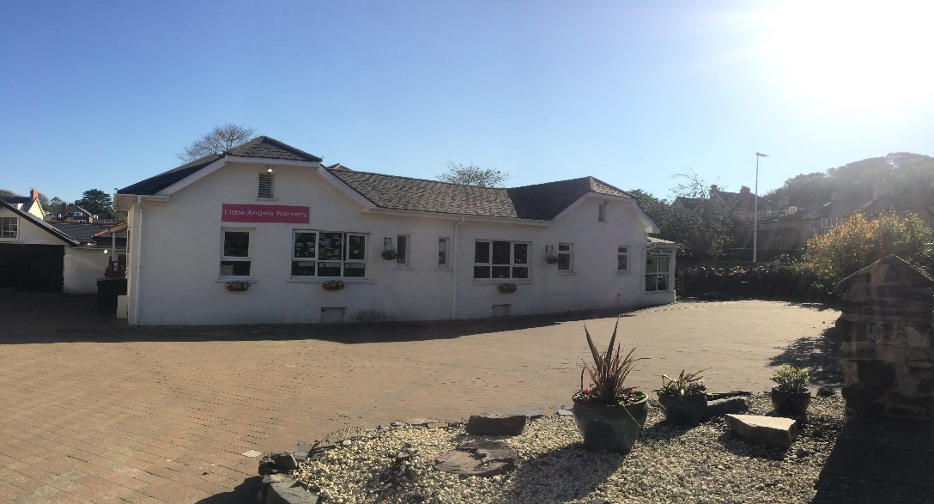
Our Nursery

Little Angels Nursery: Background

Little Angels Nursery has been operating in the Aberystwyth area since March 2007 as an independent children’s day nursery.

From the beginning Little Angels Nursery has been developed around our long standing Ethos;
“To provide a child centered approach to the care of our children, with a truly warm, homely, welcoming and caring environment. It is important to establish a friendly atmosphere and to promote a reassuring and stable setting. We strive to provide stimulating activities with indoor and outdoor games so that each child can have fun; are happy and develop to their full potential.”
We offer both full and part time places for children. The nursery is open weekdays only from 8am to 6pm. We have a transport service to and from school for children attending local schools. These extended hours provide a wrap-around service for parents and carers. Parents can chose between full day and half day sessions. We operate for 50 weeks of the year (closed one week during the August Bank Holiday and between Christmas and New Year and take Bank Holidays)

We believe that to provide the best experience for our children, all relevant people with an input to the child should work in partnership. Therefore we strive to provide partnership with parents and carers, staff from other agencies and the community at large. Through this holistic approach, we aim to provide a service which takes account of each child’s individual needs.

Our Staff Team

The nursery staff consists of a management team and care team of 22 staff. The management team includes Director Krishan Kawol, Manager Sarah Shield and Deputy Manager Alan Gbel, Duty Manager Leanne Gornall and Lyndsey Hughes-Jones operates as a Senior Administrator to assist Sarah and Alan.

The care team is carefully selected through comprehensive recruitment procedures for a blend of skills and experience to provide a broad, dynamic nursery team. We are proud to have a phenomenal staff team with a mix of age ranges, cultures and experience within the staff team.

Achievements and Successes

The Poppy Room – Little Angels strives to provide the best care and to help as many parents in the local community as possible. Therefore, when an opportunity arose to secure Welsh Government funding via Ceredigion Council Childcare Unit to expand our provision, we successfully applied for the funding and over the past year built a whole new play room, with the intention to increase the number of children we can care for to 57 children. We hope this will provide more spaces for the local community and also more space for our lovely children and staff to continue their good work.

We have, as part of the process, created an outdoor play area for the three years olds in the courtyard and have purchased new equipment to advance the children’s learning opportunities.

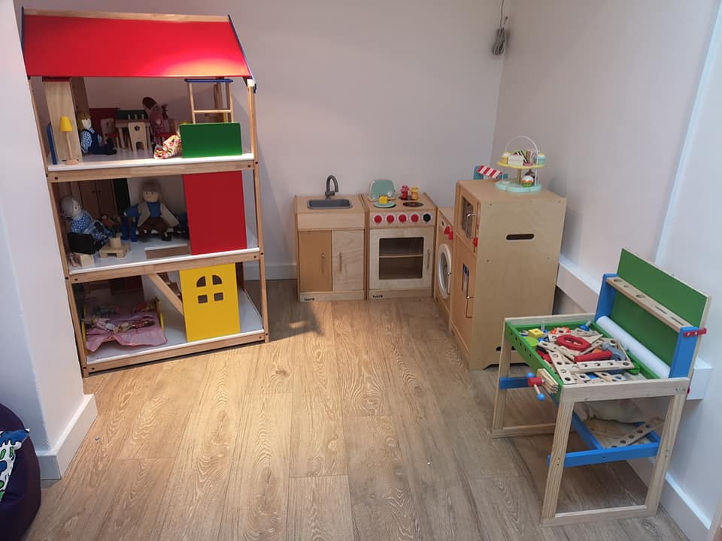
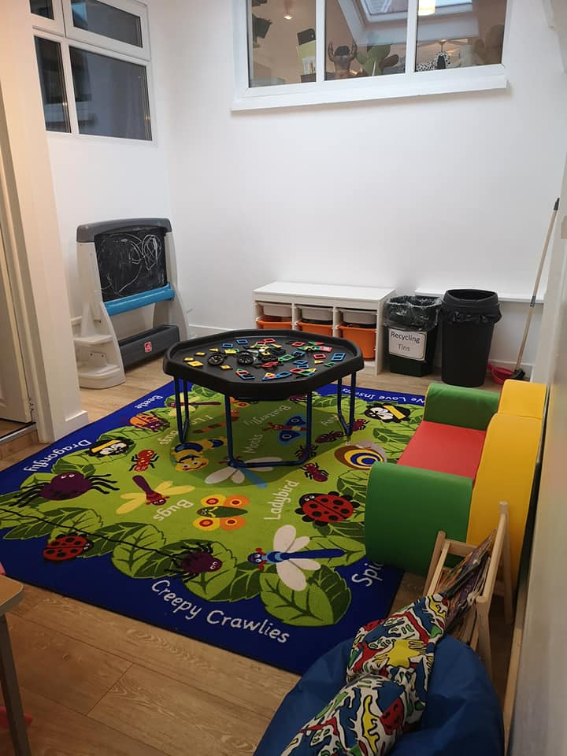

Figure 1 – Our new playroom – The Poppy room

New Sleep room – As part of our new space, we then decided to have a small move around of the building and have therefore created a purpose built sleep room with 3 wooden cots and storage for blankets and spare clothes. Where our previous sleep room used to be we have moved the Management’s office. This will be covered later in the report

Community Relationships – Little Angels has introduced a 10% discount in childcare fees to some local institutions such as Hywel Dda Health Board employees and the National Library for Wales

Designed to Smile – Little Angels has been involved in the pilot rollout of a dental care scheme for children. Sadly, our nursery no longer falls under the area for the scheme, however it has been a pleasure to be part of it.

Healthy Pre-School Programme – We have passed the area covering nutrition and oral health, mental and emotional health, wellbeing and relationships, physical activity and active play and the area of general hygiene.

Charities which children raised funds for:
- Children in Need. Our nursery children and staff raised an incredible £1727.49
- Comic relief
- Macmillan Coffee Morning Our nursery children and staff raised £150.44
- Sport relief
- Leukemia Charity
- Crackerjacks

OUR CHILDREN

Wellbeing, Care and Development

We encourage children to have a voice, In the Bluebells and Daffodils rooms, we use circle time in the mornings to enable children to make choices and decisions, this provides time for children to be listened to and value the communication children have with the staff. The staff ask each of the children questions, about what they have done at home, what is going on outside, such as the weather and to express their views on what activities they would like to do in the nursery for that day and for the week ahead, contributing to ideas for themes and topics.
Throughout the sessions all children are given the opportunity and encouraged to speak and express themselves well and communicate their needs in a variety of different ways. We have staff that are fluent in English, Welsh and Hindi and we communicate to the children giving due consideration to their home language.

For the welsh language, around half of our staff speak Welsh, as a second language, which enables nearly all children that need or request a service through the Welsh language to receive it.

Being an opened planned environment, all children get to know all the staff and the children are confident that staff understand their needs, preferences, feelings and non-verbal cues and that their individual needs take precedence over daily routines, this is supported by daily handover conversations with parents and personal profiles. Where staff do need help about a child’s preference, the opened-planned environment means that support from other staff is always readily available. With the addition of our new playroom, an intercom system has been placed in the building so that any staff in the room can contact other staff at any given time.

For child led learning and play, arts and crafts are kept at the child’s level, similarly sensory toys and sand and water play free-play is also accessible at the height of the child.

With the younger babies in the Rose room, the room planning is led by the interests of the children. We use observations as a method of recording what interests the children have and then informing our planning as such. Toys and equipment are set out and provided at the children’s level for them to initiate and engage in a range of exciting activities.

We encourage children to make choices and learn skills to be independent, we offer the 3 year olds a choice of snacks that they can choose at snack time at 3pm. They are also encouraged to dress themselves independently and serve their own lunch and puddings at lunch times. All children in the nursery are encouraged to dress independently, but the staff are always on hand to help. Children are encouraged to help in tidying up after snack times and after activities. Drinks are available throughout the day for the children, cups/beakers are kept at their level and individually labelled, where they can reach it whenever they wish with minimal risk of cross-contamination.

Children feeling safe, happy and valued, it is of primary importance that all our children feel secure, happy and comfortable and relaxed and that they feel valued and their rights are respected

We have a strong substantial core staff team working full time hours through the week, this provides a continuity of care and a strong platform for children to form bonds of affection with staff who know each child well and give them consistent care which fosters confidence and positive self-esteem. We find this is very effective and most children really cope well with separation from their parents/carers and they feel safe because they are well supported during daily transitions from the home to the service, and vice versa. This is evidenced by the happy and friendly atmosphere of the nursery created by the children.

We use a key worker system to ensure children are best settled in the nursery and to develop strong bonds with staff. This enables them to cope with separation from their parents and to form positive emotional attachments. Most children have bonds of affection with their key worker, as a result, they are comfortable, settled, relaxed and seek out familiar people who they know will help them and build their confidence. Again, on reflection, this is mirrored in the comments provided by parents on hand overs and the recent parent questionnaire.

If a child shows signs of being unsettled on starting, we welcome the parents to stay with the child and offer additional settling in sessions and the children develop new relationships with the staff and friendships with the children. We work closely with parents and the child to best support and encourage children so that they are confident that their feelings, likes, dislikes and concerns are taken into account. This is done by talking with the parents and working to the child’s ‘Personal Profile’, we are also aware that child’s or parents preferences can develop or change frequently, so we also rely on the verbal communication with parents on hand overs, where any significant needs are passed to senior staff who make notes and information passed to staff who need it as and when appropriate and then updated in personal profiles if necessary. Our staff also tracks each child through play and observations and maintains good discussions with parents during hand overs during pick up and drop off times to share information and developments. Whenever a child transitions between playrooms a new ‘all about me’ personal profile is completed by the parents under instruction from the key worker and a new key worker will be allocated to the child and introduced to the parents. A developmental tracking sheet is also completed by the previous key worker to inform the next key worker what stage they are at in nursery.

The nursery has daily routines for each room and stage of development of the children, most children are familiar with the routine and it gives them a sense of security and is developmentally appropriate for their needs. The children have a great sense of belonging at Little Angels and we see most children are excited to be stepping into the nursery each morning. As important as forming bonds with staff, we encourage and nurture the children to develop relationships and form friendships with the other children.

This can also help when children transition to school, where they can have confidence in changes along with a group of children and transport staff who they are familiar with and can trust.

Children’s Interactions are encouraged and supported by staff, who plan for and provide age appropriate toys and activities to develop children’s resilience and ability to cope. Through play and activities provided in each room younger children are supported to understand their feelings and to be sensitive to the emotions of others. Through play and activities, the staff supervise and nurture children to learn to manage their behaviour, co-operate, take turns and share. The staff also oversee younger children who are beginning to develop a sense of right and wrong.

Our staff are trained to provide the appropriate discipline for the age and developmental stage and support the children to learn and understand right and wrong and socially acceptable behaviour. Sarah Shield and Leanne Gornall are named representatives of the nursery for Behaviour Management and promote communication and good practice between staff and parents. This helps to ensure that almost all children interact and co-operate well with their peers and adults, that the children are polite and use good manners and take appropriate care of equipment and resources and that they show respect for property and people and understand the consequences of their actions.

We understand children are developing their feelings with awareness to the emotions of others; they are becoming self-disciplined and accept differences of race, gender, abilities, age and religions/cultures. We always strive to promote individuality and cultural differences.

Children enjoying play and learning is promoted at the nursery by staff involving the children in planning activities and in gathering materials to prepare for their activities and tidying up afterwards. We assess this as part of our measure in the children’s engagement in play and activities. In addition we measure children’s expressions and happiness during activities, their sustained interest in the activity and the scale of their sense of achievement from the outcome of play and activities and when they show items to their parents at the end of the day. Through the constant assessing of engagement children can influence the activities and tasks they undertake. In addition to structured and organised play we encourage and provide times in the daily routine for extended periods of child initiated, uninterrupted play as well as frequent opportunities for adults to play alongside the children.

Nursery staff reflect on activities and toys and equipment that individual children have enjoyed and when children are eager to show or talk about what they have been doing. This can be noted in the learning journals and is discussed with parents during hand overs and at staff meetings. It is reflected by nursery staff in meetings and ideas are developed further to build on previous activities or seek different activities.

As well as offering children environments for free play and with structured activities throughout the day, the nursery has defined areas within each room. There is always an area for children to relax and enjoy quiet times. This includes the comfy den corner in the Lilly room which is defined by a colourful rug, rainbow den, shelves with books and soft sofas for the children to relax. For the older children there is an IT corner and an area for children to sit and have quiet time. We have also renovated our sleep room for the comfiest possible nap time.

The rooms are assessed after each activity and frequently throughout the day by the room staff and by senior staff to ensure they are clean and safe. We provide open planned play spaces indoors and outdoors for each age group so that children are able to explore their environment freely and safely. We ensure all doors and gates are locked when an area is not in use. We are particularly cautious not to leave any doors open for opportunistic strangers to easily enter the building.

Children’s development and independence is encouraged at the nursery by staff observing the children and monitoring that they are developing emotionally, physically, socially, creatively, linguistically and intellectually.

We set skills targets for children to meet before they start school and provide activities and play to develop children in those areas. These skills include being able to put on their own shoes and having good toilet and personal hygiene skills such as undressing and dressing to use the toilet and washing hands. We continue to record observations in each child’s learning journey and discuss points of interest with parents passing information what each child is doing at nursery and at home so that we can build on their confidence and progress when trying new things. We follow a set of guidelines based on the seven areas of learning to accurately assess a child’s progress and development.

Again, the strong and consistent core staff team and key worker system supports most children have secure relationships with staff and their peers that help them gain confidence and overcome challenges.

The nursery is always seeking to introduce a good range of media and materials for the children to grow in confidence to develop creatively, experiment and be imaginative. The nursery positively encourages outdoor play and it is an integrated part of our daily routine, at least once or twice per day, we help to teach children the importance of physical exercise, healthy eating and personal safety and older children are learning about healthy relationships. This is through the access to outdoors, the variety of equipment and activities available and by the nursery leading in schemes such as the Healthy Pre-School Programme.

We monitor children’s confidence and independence by recording it in the children’s learning journals, following our seven areas of learning guidelines and in hand over’s with the parents.

Children’s Development and Planning

We have developed and continually review routines for each room of the nursery which are displayed on the walls. These include indoor and outdoor play on a daily basis with free play and structured activities for the children.

We operate a Key worker system. This supports staffs awareness of each child’s care routine to ensure individual needs are being best met. This includes their food, nappy changes and sleep routines. We continually work with parents to manage routines at home and the nursery.

The nursery works closely with third party organisations such as Helping Hands and Flying Start and recently the Department of Work and Pensions to provide assistance with children and parents attending the nursery when required.

We continue our development of communication with parents through the use of notices in the main entrance, through quarterly newsletters, Facebook page, the nursery website and email.

To ensure that all children are provided with appropriate early intervention strategies, which takes account of the child’s needs, we have in this past year worked together with parents, health visitors, speech and language therapists and special needs coordinators, to progress Individual Educational Plans for particular children.

To provide further opportunities to support and develop our Partnership with parents, we provide a Daily report sheet of the child’s daily activities in the nursery, food and personal care. We ask parents to review their child’s Observation files and understand its role in their child’s development and progression.

Wellbeing Internal Rating – Excellent

Care and Development Internal Rating - Excellent

PRACTITIONERS

Quality of Staffing

We are proud to have recruited and trained dedicated, enthusiastic and very competent members of staff, who have worked at the nursery for many years and promoting the nursery ethos of quality and safe childcare. Staff work to developing relationships the families and parents well and our high standards promote professionalism both within working time and outside of work. It is the standard of the nursery, that any action by a staff member both inside and outside of the nursery at any time is a reflection of the quality of our staff team as a whole. All our staff have relevant and valuable experience to work with children and in nurseries, our internal training is very thorough and we believe that it is the attitude and personality of a staff member that is their greatest asset. All staff have or are working towards gaining their NVQ Level 3 or equivalent.

The management team has comprehensive communication processes to ensure the highest quality of care, safety and sharing of information and formally we monitor staff with ‘six week appraisals’ conducted on all staff as required by national minimum standards. As childcare professionals, all staff are trained in Child Protection and First Aid. There is a significant staff training budget set each year to support staff to attend courses/training and to continue their professional development. Most recently we have had 1 staff members complete their level 3, one member of staff has completed their level 2, and is carrying on towards level 3 and 2 others working towards their level 3. There are also 2 members of staff that have completed their Playwork qualification. Other staff have attended training on Elklan, sign-a-long, ‘Incredible years’, Intensive interactions course, Welsh training and ‘Fit in 5’.

Our staff team is thoroughly vetted and a disclosure procedure is processed before staff are offered a position. Each new staff serves a probationary period and placed with a mentor who leads them through an induction process and who can help them settle in to the nursery and can approach with any need that may arise. New staff have monthly reviews with management to ensure they work suitably and to the standard of the nursery setting. Our staff team have qualifications which cover NNEB, NVQ levels 2, 3, 4 and 5 in Childcare, Education, Early years development, Management and Customer Service.

All staff undertakes a six weekly individual appraisal, in addition monthly staff meetings are held so that any issues can be raised between the whole staff team and every member of staff can feel included in how the nursery is operated.

On an annual basis, staff meet with the Managers to review their performance, identify areas for improvement and to set targets for their own personal development regularly. This then allows further training and opportunities for Continuous Professional Development to be explored and accessed.

As well as this we have brought in an Employee of the Month scheme, as well as a Display board of the month scheme to give recognition for all the hard work we do.

Last year we invested in some new furniture and equipment in the staff room to make the staff as comfortable as possible and make the most out of their down time on their breaks. This year we have followed this up with a comfortable work space by giving the office a makeover, with all new equipment and including another desk to allow staff members to be able to complete any paperwork in a comfortable and professional space.
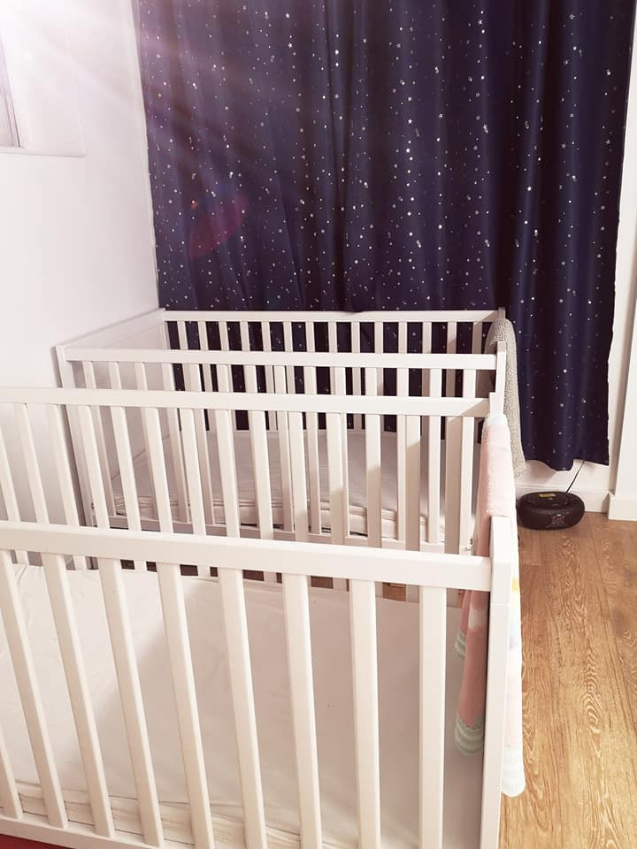
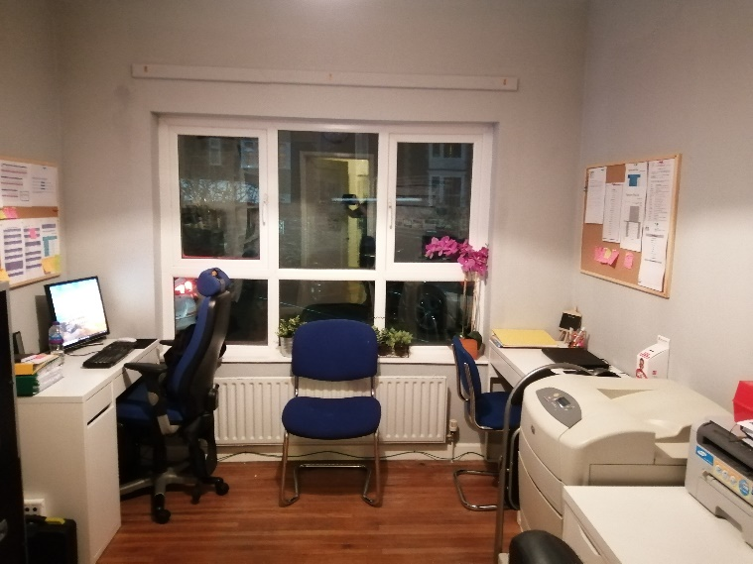
Figure 2 – Our New Office and Sleep Room

Views of Staff

Staff questionnaires (Appendix B) were distributed in September 2019 to gauge the views of staff at the nursery. 20 questionnaires were distributed and 15 questionnaires were returned with a 75% response rate.

For consistency the staff questionnaire followed the format of the previous year with 22 questions and getting the best information and views of staff. The responses for every question were strongly positive showing staff are very happy in the working environment, with the management, colleagues, the children and parents. With such a unanimously positive response we have summarised the data in Figure 3 - Response to every question from Staff Questionnaire below.

Table 1 - Results from Staff Questionnaire
No. | Question | Yes | No
1 | I enjoy the age group you are working with. | 100% | 0%
2 | There is appropriate toys and resources available. | 100% | 0%
3 | Staff regularly discuss how to improve the achievement of all children. | 100% | 0%
4 | Staff provide activities which meet the learning needs of all children. | 100% | 0%
5 | Staff regularly involve children in arranging play activities and how they can be improved. | 92% | 8%
6 | Parents are involved in the nursery and their children’s learning. | 92% | 8%
7 | I am aware of the nursery’s procedures relating to child protection. | 100% | 0%
8 | I am aware of the nursery’s aims and ethos. | 100% | 0%
9 | I have been included in developing the nursery’s aims and values. | 92% | 8%
10 | I feel part of the staff team. | 100% | 0%
11 | Staff communicate effectively with each other. | 100% | 0%
12 | I have good opportunities to take part in continuing professional development | 92% | 8%
13 | I would benefit from some specific training. | 45% | 55%
14 | Staff across the nursery share good practice. | 100% | 0%
15 | I am happy with the role I play within the nursery. | 92% | 8%
16 | I received relevant and comprehensive induction training. | 92% | 8%
17 | I receive sufficient guidance and support from managers. | 100% | 0%
18 | I can raise any concerns with the management. | 100% | 0%
19 | I have full confidence in the leadership of my manager. | 100% | 0%
20 | I have full confidence in the leadership of the directors. | 100% | 0%
21 | Leadership at all levels is effective. | 100% | 0%
22 | I am aware of the leadership structure within the nursery | 100% | 0%
23 | I feel included by room leaders in all jobs and tasks | 100% | 0%
24 | I am actively involved in setting priorities and improving the nursery. | 100% | 0%

The questions asked to staff included:

I feel part of the staff team. (100% said ‘Yes’), the same as last year

Staff communicate effectively with each other. (100% said ‘Yes’) up by 13% on the previous year

I have good opportunities to take part in continuing professional development (92% said ‘Yes’), down 2%, we have worked on training courses for all staff over the past year

I enjoy the age group you are working with. (100% said ‘Yes’), same as the previous year

Looking at how staff view management the following responses were consistent with the previous year
Leadership at all levels is effective. (100% said ‘Yes’)

I received relevant and comprehensive induction training. (92% said ‘Yes’) and 8% said ‘No’ Down by 8% on last year.

I receive sufficient guidance and support from managers. (100% said ‘Yes’) same as last year

Comments made by the staff include:

“Managers are very easy to approach and always feel confident to go for support.”

“More visits outside the nursery, and maybe inviting more individual educational companies to the nursery.”

“More toys so we can rotate them and more use of outdoors”

“More storage, more choice of toys in every room”
“To receive equipment when requested. More outside visits”
“I would benefit from some 1:1 support training.

I would like to move higher within the nursery.

Refresh of toys to stop the children getting bored (so many toys are incomplete)”

“I would benefit from speech and language training. More trips and days out. Overall it’s an amazing nursery :)”

Since receiving the questionnaires we have:

Invested in lots of new toys and equipment for all rooms with new storage options

A big blitz to put all toy parts together has been done and rooms are swapping toys and resources amongst rooms more readily.

New building work and room equipment are being discussed with our maintenance staff to make each room bespoke and adaptable for all children.

The Bluebell toilet has had a revamp

We are actively looking for extra training for all staff, particularly in the areas they have requested.

We are on the search for more opportunities for educational/ activity companies to visit the nursery, whilst also looking for ways that we can get out of the building more to get the most out of the local surrounding.

Last year’s comments to action were:

“Training in Welsh, Speech and Language, Learning difficulties, SEN, computers.”

“Take the children on more trips/outings”

“A larger premises would be good. A new kitchen. Plastering on building. More team building. More outings. Family involvement events.

“Training in Forest school, speech and language and Autism course.”

“Training on forest school and Elklan.”

Keeping children safe and happy, we have a really good approach to child safety at the nursery, we are very proud of our safety record, we encourage fun, laughter and child initiated activities and play. Staff actively interact with children during play and activities to reflect enthusiasm and reassurance and develop children’s confidence and promoting positive behaviour.

We ensure all children are supervised at all times, children are never left in a room alone and the nursery environment has been purposefully designed to support supervision across the open-planned rooms. We train our staff to ensure they are always facing the children so that staff can see what is happening at all times. We train our staff not to sit unnecessary or have their hands in their pockets, so that they can actively interact with all children during activities and be prepared to help children at all times. We have trained our staff to high standards of communication so that all staff are well informed to be an effective member of the staff team. We work hard to ensure staff do not have information overload, which can negatively harm efficiency and decision making. Any time taken for administrative purposes is time away from supervising or interacting and developing the children, this can potentially put the child at risk or delay development, which is our primary objective. Therefore any administration must have a very good reason for being done.

It is our policy to ensure children are physically active daily, this includes playing outside twice daily.

Our outdoor and transport procedures are robust and we always account for the children that are entering and leaving the nursery, on advice of the inspector we have updated the children’s registers to now include the exact time of arrival and leaving.

Doors are never left open and are locked to insure that nobody can enter into the premises uninvited.

We train all our staff to consider health and safety in the workplace and food hygiene in the kitchen and provision for infection control. To enable cleaning of toys we have a second dishwasher in the nappy changing area, primarily used for toys cleaning. Each room has a routine and rota of toys cleaning arranged by boxes so that toy cleaning in each room can be audited and forms part of the management quality assurance checks

Staff are involved in fire safety training and application in the nursery. Fire alarm tests are conducted and fire drills are conducted monthly.

The staff are involved in the ‘Healthy Pre-School Programme’ and we promote healthy life styles by treating staff to fruit bowls as a substitution to the usual cakes and sweets as a thank you for their hard work and dedication, we also encourage staff on using alternative modes of transport or public transport to work.

The nursery has a robust procedure in the safe administration of medication. Once a year we perform a quality review and of 75 mediation forms checked there were no forms filled out incorrectly or incomplete.

We support all children to develop to their full potential, where it is identified that children need additional support, we will work with the child, parents and professional agencies in supporting children with medical conditions

It is the policy and requirement for all of our staff to be trained in administering first aid, new staff and refresher courses are an on-going training need. As mentioned, we have a training budget available for staff and additional resources are available on request. We have a member of staff dedicated to sourcing external training.

We consider the safety on outings and visits as paramount importance for all our children and staff and the public. All outings, staff and children are risk assessed to the activities and environments in which they will be exposed to outside the nursery grounds. We ensure there is sufficient staff on all outings and staff take an emergency pack with them. This includes a telephone, emergency contact details, first aid kit and high-visibility jackets for the children.

Any IT activities are risk assessed for the suitability and developmental stage of the children. Where appropriate a staff member will supervise, observe and monitor the children using computers to guide them to learn and maximise the enjoyment from the activity. It also ensures that children only access appropriate material on the internet. We also have security and adult content filters on nursery computers.

Managing interactions, we always ensure that staff work in line with the nursery behaviour management policy, we have recently expanded on detail and updated the policy to ensure the policy is most relevant to the way in which the nursery works.

All staff are monitored throughout the day by management and the management check on any behaviour management instances that may arise to ensure that staff are consistent in their approach, having regard to individual children, so that there is no confusion in the child’s mind as to what is/is not acceptable. All staff are to set good examples and be wonderful role models Staff attend regular staff meetings where this information is disseminated and discussed to ensure all staff use the appropriate and consistent approach for each individual child.

Management and room leaders ensure that staff set realistic boundaries and use appropriate sanctions having regards to the child’s stage of development. This practice is underpinned by training and qualifications in childcare. If a child is acting inappropriately then depending on the age of the child we will gently deflect and ignore the child’s focus from the negative action and gain the attention and focus of the child into another activity, where they can be praised for positive behaviour.
In the rare instances that we are unable to distract the child and influence them towards more positive actions, we will sit the child on the floor, (where they are located at the time and as long as it is safe,) for a moment to think, again the length of time is dependent on the age and development of the child.

Management ensure staff are modelling good behaviour, staff are professional at all times in the rooms, during breaks, on outings and when off-duty.

Children’s development and individual needs are a long-standing area in which the nursery excels. As evidenced from the ‘Top 20 Nurseries in Wales’ Award voted by parents, we are a nursery that delivers in the provision of a nurturing and caring atmosphere, a welcoming environment and responsive care and this is recognised by the parents who voted for us.

There are strong relationships between the staff team and the Management team and are more of a family than work based. This close relationship is extended and reflected with the parents which strengthens the information, knowledge and understanding of the children to meet individual needs and abilities. This is a relationship of trust, this cannot be regulated for or artificially created, it is personal to the staff and the parents and we clearly do it well (see parents questionnaires). This personal and emotive information is sensitively shared with staff team in each room. It best enables us to promote equality and diversity and treat all children with dignity and respect, promote the development of all children by planning for a good variety of play, learning, recreational and leisure opportunities and implement the principles of the Foundation Phase for children aged 3-7 years old. This close relationship with the parents can be evidenced by the overwhelmingly positive responses and fantastic comments from our parents.

We are fully committed to supporting children with additional learning needs and we have very close links to specialised support teams such as speech therapists and Health Visitors, as well as always having good communication with parents if any concerns of a child may arise. One of the Directors is a Health Visitor and updates the nursery with information. To ensure any potential issues are identified early, we track developmental stages and areas in the learning journey file. We set a baseline against the Seven Areas of Learning and the ‘Birth to 3 matters’ framework and staff are expected to conduct monthly reviews of each child progress. The children’s files are updated and this information is made available through the informative hand-overs and the children’s Learning Journey files are available for parents and carers at any time.

Staff are caring, nurturing and responsive to individual children’s needs, it is our mantra to treat each child as if they were our own.

We are a culturally diverse team, both female and male staff from across Wales, the UK and international staff. We value the children’s home backgrounds and encourage children to express their individuality.

We ensure staff promote children’s rights well and understand their responsibilities under the UNCRC.

Having such a strong inclusive recruitment policy, we have successfully built on a breadth and depth of cultural diversity to have great confidence we are promoting tolerance, equality and diversity well; and encourage children’s curiosity about their own and other people’s lives and beliefs.

THE ENVIRONMENT

We are very proud of our leadership which has helped shape the environment of the nursery both indoors and outdoors, it is friendly, safe, warm and welcoming. The nursery staff works hard to ensure that the children are always cared for in a safe, clean and secure environment.

During the start of every day staff check and set up each room ready for the children, all staff check toys and equipment that they put out. Room leaders have overall responsibility for health and safety in their room. Any broken items or concerns are reported to the office for management to action. Before children go to play outside, the outdoor play area is also checked for safety. The responsible person for the outdoor area is Naomi Pratt. During the day staff and children help to clean up and show respect for toys and equipment after activities and to help clean up food, plates and cutlery after lunch and snacks. Food areas are wiped clean and sanitised, again staff are trained to risk assess each activity so that it is suitable for the age and developmental stage of the children who are to participate. Where appropriate unnecessary risks are eliminated and staff carefully balance protecting children from harm and the development of children’s judgement and independence.

At the end of each day the staff tidy up the toys and equipment and an external cleaning contractors is employed to clean the rooms. Management ensure there are good systems in place to ensure regular maintenance and safety checks. Hazards are quickly identified and addressed and safety records are kept up to date.

The management team ensures that effective risk assessments are comprehensive, regularly undertaken, reviewed and acted upon to ensure children’s safety and that they communicated well to those using or working at the service.

Emergency procedures have been written and these are displayed by exits. The manager or person in charge is aware of responsibilities of evacuation procedures and this is tested on a regular basis.

Safety of the premises are ensured by having a contract for the boiler serviced and checked annually, similarly a contractor ensures the electrical equipment is PAT tested annually, weekly visual checks of cords and wires are made by the manager. Fire extinguishers are serviced annually by a contractor. The fire alarm system is tested annually by a contractor, call points are tested weekly and emergency lighting is tested monthly. Major maintenance work is carried out during the weeks of closure in August and December.

The Manager ensures the suitability of premises and outside play areas are secure, welcoming, friendly and provide a rich environment for play and learning. We have a rolling programme of outdoor cleaning, weeding, trimming and gardening to have a welcoming environment and painting when the weather allows, to keep the outdoor areas clean and colourful.

The manager has split the outdoor area into three distinct parts each with a different flooring type to enable a variety of activities both structures and independent playing, in a useable space environment. It is the general policy to have each room play outdoors at least twice a day, this is somewhat weather permitting, although all-in-one rain suits are available at all times designed for all weathers. We have discussed more options to make the outdoor areas more all-weather friendly.

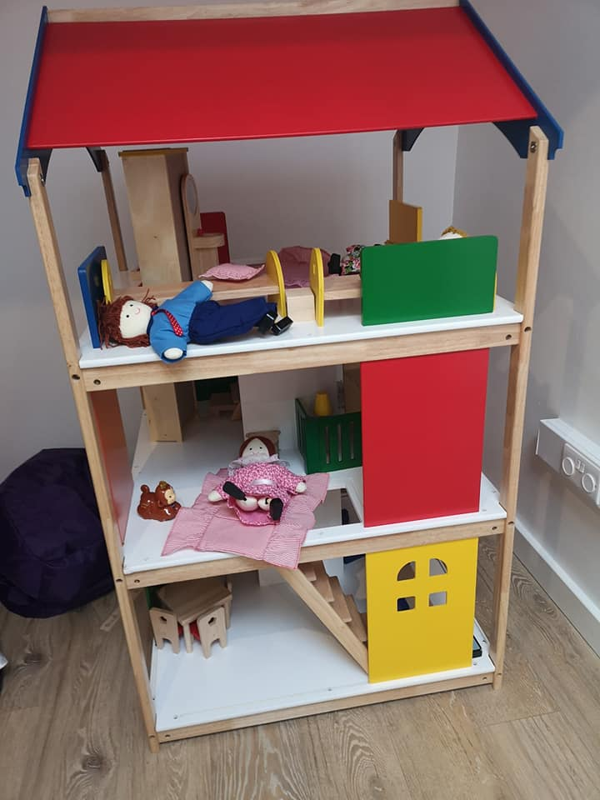
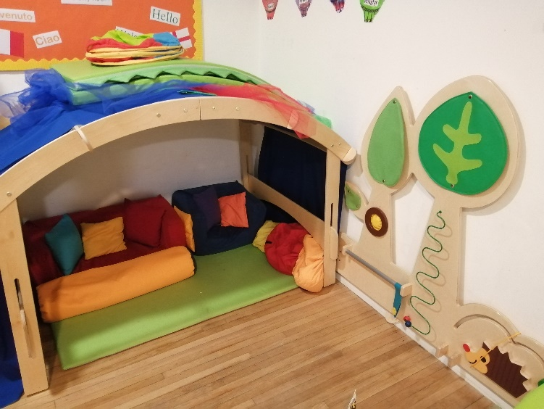
Figure 4 – A sample of our new equipment. Comfy sensory corner for our toddlers and small world dolls house for our preschoolers

There are suitable facilities for staff and for confidential conversations, we can easily access and speak confidentially in the staff room and manager’s office. Similarly, we speak with parents in the staff room or the manager’s office depending on the conversation. The management ensure the environment is well planned to reflect the needs and interests of the group of children using the space.

Quality of resources and equipment are constantly monitored and discussed with each room and at staff meetings so that children have access to furniture, equipment, toys and materials that are appropriate and suitable for their needs. On a daily basis, management monitor each of the rooms to ensure resources are of a suitable design and condition, well maintained and conform to relevant safety standards. Each room has a monthly budget for toys, equipment, arts and crafts. The staff of each room places a purchase order to the manager to agree, discuss how they fit into developmental areas and then actions purchases with reputable suppliers.

Similarly, at the start and end of each session, lunch and the day management check resources are clean and their maintenance complies with infection control principles.

When procuring new toys and equipment we consider toys and play materials to promote cultural awareness and equal opportunities, this is consolidated by the multi-cultural backgrounds and appearance of our staff as well. The director Krishan Kawol is an active member of BAME ethnic minority group in the Civil Service and promotes opportunities for minority groups in Wales, the essence of this is fed directly into our children and staff development and respectfulness.

We also consider the size of the equipment is suitable for the children and there is enough for the size of the group. Most importantly toys and equipment needs to be stored safely and appropriately and the manager is regularly assessing storage options at the nursery both indoors and outdoors.

The outside area provides appropriate play and learning opportunities, activities and resources are rotated to promote and maintain enthusiasm for a range of toys and activities including physical and imaginative and creative play.

The Environment Internal Rating - Excellent

LEADERSHIP

Leadership and management have a long term vision to provide the highest quality of childcare and a continuity of care as a service provider to the community. This means that the service must work within its financial capabilities and be sustainable.

This year we are celebrating being in business for 13 years and are looking forward to many more years of offering the service.

The management and all the team are passionate about the service we offer. We clearly communicate the vision and purpose of the nursery to the parents, however, this cannot be put into written words easily, but the warmth, love and care is in abundance as soon as you walk into the nursery. The service is purely focused on the care of all the children and the service is provided by a ‘family staff team’.

Safety is out prime objective, we are entrusted to care for the children, and we take this responsibility seriously. Although we are constantly assessing and balancing between safety and developing children’s independence.

The Director is fully involved in the service provision, the director ensures that he speaks with parents when appropriate during pick up and drop off times.

The setting is constantly self-evaluation and planning for improvement. On a daily basis, the manager works with the senior staff to monitor and discuss the rooms, the children, their behaviour and the staff in the rooms to ensure the most effective childcare provision and child development. Management prompts staff to reflect and discuss what went well and areas where activities, routines and care can be improved on. The director visits each room and communicates with all the children through play and discusses outcomes with management and room leaders.

The management and directors regularly meet to plan ahead for resources, service demand, services we can offer, staffing levels and financial aspects of the nursery.

The manager and senior staff conduct supervisions every 6 weeks and annual staff appraisals. The directors regularly hold meetings with the management and with care staff. In addition, the director ensures they speak directly with parents to open communication channels with parents and to gain understanding of the service being provided.

Leadership and Management Internal Rating - Excellent

VIEWS OF PARENTS AND CARERS

Parent Questionnaire

The views of parents are highly valued and a composite part of the nursery service. Parent questionnaires (Appendix A) were sent out in September 2019 to enable us to gauge how service users view our service. 77 questionnaires were distributed to parents, of these 29 questionnaires were returned, with a 38% response rate.

The questions comprehensively seek views of parents on the areas of Child Welfare, the Nursery Environment and Parent and Nursery relationships. The questionnaire has been modified with just three questions similar or the same as the previous year to enable a year on year comparison. There was a highly positive theme to responses and confidence of the service by the parents.

Results are based on the scoring scale of (agree, strongly agree, disagree, strongly disagree, don’t know) for all the questions answered by the parents showing they were extremely happy with the overall service. Parents consistently ‘strongly agreed’ with the service questions and almost 100% either agreed or strongly agreed.
Parents Questionnaire
Question 1 - We asked new parents the question “My child is happy being at this setting.” Figure 5 shows that as with the previous year, 93% strongly agreed with the remaining 7%.
Figure 5 - My child is happy being at this setting?
Question 2 – Parents were asked “Staff treat my child fairly and with respect “ Figure 6 shows 90% of parents strongly agreed and 10% ‘agreed’.

Figure 6 - Were staff inviting and helpful on your first visit?
Question 3 – We asked parents “I feel my child is safe at the setting” 97% of parents agreed with this statement and 3% ‘agreed’.

Figure 7 - Did you settle your child, to suit you?

Question 4 – We asked parents to rate the following statement “My child's behaviour is managed effectively.” 86% of parents ‘Strongly Agreed’ and a further 14% agreed. No parents disagreed.

Figure 8 - My child and I feel welcome in the nursery

Question 5 – We asked parents the question “The setting helps my child to feel confident.” The vast majority 90% of parents ‘strongly agreed’ and the remaining 10% ‘agreed’. No parents disagreed

Figure 9 - My child enjoys being at nursery

Question 6 – We asked parents the question “I feel staff really know my child as an individual”. Once, again, we had a positive response with all parents, 86% ‘strongly agreed’ with the statement’, 10% ‘agreed’ and 3% ‘did not know’.

Figure 10 - I am happy with the quality of care my child receives

Question 7 – We asked parents if they agreed with the statement “The learning experiences my child has at the setting are at the right level for them.” 90% of parents ‘strongly agreed’ with the statement and the remaining 10% agreed. No parents disagreed.

Figure 11 - The learning experiences my child has at the setting are at the right level for them.

Question 8 – We asked parents if “My child's learning and development is well supported by the staff in the settling.” Again responses from parents were positive, 90% of parents ‘strongly agreed’ with the statement, 7% agreed and 3% “did not know”. None disagreed.

Figure 12 - My child's learning and development is well supported by the staff in the settling.

Question 9 – Parents were asked if “My child is encouraged to be healthy and physically active.” Most parents ‘strongly agreed’, 86%, 10% ‘agreed’ and 3% “did not know”. Again, no parents disagreed.

Figure 13 - Outdoor play areas are clean, safe and well equipped

Question 10 – We asked parents to rate the statement “The setting supports my child’s emotional wellbeing.” responses from parents were positive, 90% of parents ‘strongly agreed’ with the statement, 7% agreed and 3% “did not know”. None disagreed

Figure 14 - The setting supports my child’s emotional wellbeing.

Question 11 – We asked parents if “My child is making good progress at the setting.” This was positive with 90% of parents who ‘strongly agreed’ and the remaining 10% ‘Agreed’.

Figure 15 - My child is making good progress at the setting.

Question 12 – Parents were asked if “I receive helpful, regular feedback about how my child is learning and developing e.g., informal feedback, reports.” The majority of parents, 79%, ‘strongly agreed’, 17% ‘agreed’, 3% of parents disagreed. This question was comparable to a question asked last year which had more positive responses with 93% of parents who ‘strongly agreed’ and 7% who ‘agreed’

Figure 16 - I receive helpful, regular feedback about my child’s learning and development.

Question 13 – Parents were asked if they get “regular, accurate and helpful information about my child’s development and progress.” 86% parents ‘strongly agreed, 7% ‘agreed’ and 7% ‘did not know.’

Figure 17 - Information I receive about my child’s learning and developing is shared with me.

Question 14 – Parents were asked if “I understand how the setting monitors my child's progress in learning.”, 93% of parents ‘strongly agreed’ and 7% agreeing.

Figure 18 - I understand how the setting monitors my child's progress in learning.

Question 15 – We asked parents if “The setting gives me ideas on how to support my child's learning at home.” 59%, ‘strongly agreed’ with the nursery approach, 31% of parents ‘agreed with the statement. The remaining 7% disagreed and 3% did not respond.

Figure 19 - The setting gives me ideas on how to support my child's learning at home.

Question 16 – Parents were asked if “The setting takes my views into account when making changes.” Again the parent responses completely supported the approach to the nursery and the partnership and relationships we have with each of the families we care for. Just 69% of parents ‘strongly agreed’ with the statement 21% ‘agreed’ and 10% ‘did not know’.

Figure 20 - The setting takes my views into account when making changes.

Question 17 – We asked parents if “I feel comfortable approaching the setting with questions, suggestions and/or a problem.” 79% of parents ‘strongly agreed’ with the statement and the remaining 21% ‘agreed’. No parents disagreed.

Figure 21 - I feel comfortable approaching the setting with questions, suggestions and/or a problem.

Question 18 – Parents were asked if “The setting is well led and managed.” The vast majority of parents, 90%, ‘strongly agreed’ and the remaining 10% ‘agreed’.

Figure 22 - The setting is well led and managed

Question 19 – We asked parents if “The setting encourages children to treat others kindly and with respect.”, 86% ‘strongly agreed’ and 14% ‘agreed’.

Figure 23 - The setting encourages children to treat others kindly and with respect.

Question 20 – We asked parents if “I would recommend the setting to other parents.”, 93% ‘strongly agreed’ with the statement (up by 7%) and 7% ‘agreed’.

Figure 23 - I would recommend the setting to other parents.

Question 21 – We asked parents if they though “My child was well supported as they started at the setting or moved to a new room.”, 90% ‘strongly agreed’ with the statement and 10% ‘agreed’.

Figure 23 - My child was well supported as they started at the setting or moved to a new room.

Question 22 – We asked parents if they believed that “Overall, I am satisfied with the setting.”, 93% ‘strongly agreed’ with the statement and 7% ‘agreed’.

Figure 23 - Overall, I am satisfied with the setting.

Question 23 – Parents were asked if they were “happy with the meals and snacks provided at nursery.” Just 69% of parents ‘strongly agreed’ and 21% ‘agreed’. 7% disagreed. This was a question that was comparable to the previous year which had a better positive response, 93% of parents ‘strongly agreed’ that they were happy and confident with the food provided at the nursery and the remaining 7% ‘agreed’.

Figure 24 - I am happy with the meals and snacks provided at nursery

Question 24 – Parents were asked if “I am happy with the snacks and breakfast that is provided.” The results show 83% ‘strongly agreeing’ No parents disagreed, the remaining 17% ‘agreed’.

Figure 25 - I am happy with the snacks and breakfast that is provided

Question 25 – We asked if parents are “I feel the nursery is well maintained and looks welcoming.” 83% of parents ‘strongly agreed’ and the remaining 17% ‘agreed’.

Figure 26 – .I feel the nursery is well maintained and looks welcoming.

Parent Comments

Comments from parents in the survey included:

“My child loves nursery, especially the staff and the food. Thank you so much”
Please can we have a new buggy shed. This hasn’t been the easiest of years for my child but he has blossomed, thank you.

He absolutely loves Bluebells, and the staff have been completely brilliant with potty training absolute stars.”

“Wonderful staff, excellent support and work with any issues we have with behaviour.
Sarah Manages the nursery so well, Alan is fab too.”

“More feedback on our child’s behaviour, personality, issues, fears, emotions, progress etc. would be appreciated. As well as a list of ingredients of the meals for parents. “

“Excellent nursery, we definitely made the correct choice in choosing Little Angels.”

“it would benefit to see achievement/progress assessments forms when our child leaves a room, it would help to reassure parents and help them understand their child’s achievements.”

“We haven’t felt personally that the key worker system is consistent”

“We fully appreciate the daily Facebook posts- we realise that this takes a lot of work but we have found it completely valuable and love to check on our son’s days’ activities.”

“We are very pleased with the increase in the Welsh language that our son has been using in the past 6 months.”

“I am very happy with the Nursery overall; my child really enjoys it! A big thankyou to the Bluebell staff, who has helped my child massively over the past few months and encouraged so much Welsh, when I expressed my concerns! He is always cared for and we love hearing his fun-filled days in the Bluebell Room.”

“I really feel you do the best with the space and location available-and although I understand it must be frustrating that you are unable to take on more children or give them more room as you are(quite rightly) so popular- We love the cosy homely nature of the building- it really helps the children feel secure I believe, and I love that you are in the town- not too far if there is an issue- really I’m just trying to say we think Tyn Rhos is perfect for Little Angels.”
“We love that there is a low turn-over of staff- a testament to your excellent management- as so many have been here (and will continue to be) since my child started. That has really helped my child settle in and feel at home with you all.”

“I really appreciate the fact that the nursery isn’t full to the brim with toys/screens/gadgets as it encourages children to be more imaginative. Play with each other shows that staff actually interact with the children.”

“the toys and equipment you have is just right- the right balance of development/educational fun- but of course your best resources are your amazing wonderful staff.”

“My child has been incredibly happy at Little Angels she has developed socially & in every aspect partly due to her time with you. Support has been amazing we really could not have chosen anywhere better for our child. Thank you!”

“Little angels is truly an amazing nursery. The staff are all so kind and friendly and have helped her develop so well. I couldn’t have done it without you. Thank you”

“The support received when settling in was outstanding. Taken at the child’s pace fully supported by the staff and manager.”

“I suggest a self-closing gate to the car park as my child sometimes runs down the ramp without me, and I fear he will run out to the road if the gate is left open, due to a parent forgetting to shut it.

“I am happy and confident leaving my daughter each morning when I drop her off- I know she enjoys all the activities throughout the day. Always a detailed handover. The environment is safe and the atmosphere is always happy and fun. I always recommend
Little angels to friends and family without a doubt it’s THE BEST NURSERY”

Action taken since our last review

In our previous review there were a couple of suggestions brought forward by parents suggesting ways we can improve our service and as we are always looking to be the best we can possibly be we have taken these on board and put them into action. Below is a selection of the suggestions made and how we have taken action to improve them.

- ‘“no one has spoken to me regarding development.” – A complete review of our developmental standards was made to make it more parent friendly and regular reviews have been included in the children’s learning journey files, which are available to parents at all time.
- “as my daughter does the same days each week I would like to see more of a rotation on meals. She seems to have Fish fingers a lot.” – In the past year we have changed supplier of our meals and have an open communication with the supplier if any changes need to be made and we are actively involved in the development of the meal plan to make it both as healthy as possible and as tasty as possible
- “the car park can get very dark in the winter and it is hard to see. Some parents park in awkward spots” – Safety of our parents and children is paramount, therefore we have installed motion sensing safety lights in the car park and new parking lines have been drawn up, along with a no parking/turning circle area for the safety of everyone.

We are continually looking to improve our provision and act upon every suggestion, no matter how small, to make Little Angels Nursery the best it can possibly be. Any suggestions that have been expressed in this current review will, or have already been, acted upon.

References

Staff Questionnaire – September 2019

Staff Appraisals - January 2019

Staff Meetings – General staff meetings held monthly for team consultation and communication.

Parent Questionnaires & Comment Cards 2018/19 - distributed to all parents in September 2018 and for all leaving children/parents throughout the year.

Appendix A

Parents Questionnaire

Dear Parents
Each year we ask our parents to complete a service questionnaire, we need your help so that we can continue to offer quality services and provide the highest level of care for your children.
If you wish to be anonymous that's fine, but please include your child’s age for our reports.
1. What is your name? (Not necessary if you wish to keep confidential)

....................................................................................................

2. How old is your child?

Under 12 months
1-2
2-3
3+

3. My child is happy being at this setting

Strongly agree
Agree
Disagree
Strongly disagree
Don’t know

4. Staff treat my child fairly and with respect

Strongly agree
Agree
Disagree
Strongly disagree
Don’t know

5. I feel that my child is safe at the setting

Strongly agree
Agree
Disagree
Strongly disagree
Don’t know

6. My child's behaviour is managed effectively

Strongly agree
Agree
Disagree
Strongly disagree
Don’t know

7. The setting helps my child to feel confident

Strongly agree
Agree
Disagree
Strongly disagree
Don’t know

8. I feel staff really know my child as an individual

Strongly agree
Agree
Disagree
Strongly disagree
Don’t know

9. The learning experiences my child has at the setting are at the right level for them

Strongly agree
Agree
Disagree
Strongly disagree
Don’t know

10. My child’s learning and development is well supported by the staff in the setting

Strongly agree
Agree
Disagree
Strongly disagree
Don’t know

11. My child is encouraged to be healthy and to be physically active

Strongly agree
Agree
Disagree
Strongly disagree
Don’t know

12. The setting supports my child’s emotional wellbeing

Strongly agree
Agree
Disagree
Strongly disagree
Don’t know

13. My child is making good progress at the setting

Strongly agree
Agree
Disagree
Strongly disagree
Don’t know

14. I receive helpful, regular feedback about how my child is learning and developing e.g. informal feedback, reports and learning profiles

Strongly agree
Agree
Disagree
Strongly disagree
Don’t know

15. The information I receive about how my child is learning and developing is shared with me when I request it

Strongly agree
Agree
Disagree
Strongly disagree
Don’t know

16. I understand how the setting monitors my child’s progress in learning

Strongly agree
Agree
Disagree
Strongly disagree
Don’t know

17. The setting gives me ideas on how to support my child's learning at home

Strongly agree
Agree
Disagree
Strongly disagree
Don’t know

18. The setting takes my views into account when making changes

Strongly agree
Agree
Disagree
Strongly disagree
Don’t know

19. I feel comfortable approaching the setting with questions, suggestions and/or a problem

Strongly agree
Agree
Disagree
Strongly disagree
Don’t know

20. The setting is well led and managed

Strongly agree
Agree
Disagree
Strongly disagree
Don’t know

21. The setting encourages children to treat others kindly and with respect

Strongly agree
Agree
Disagree
Strongly disagree
Don’t know

25. I would recommend the setting to other parents

Strongly agree
Agree
Disagree
Strongly disagree
Don’t know

26. My child was well supported as they started at the setting or moved to a new room

Strongly agree
Agree
Disagree
Strongly disagree
Don’t know

27. Overall, I am satisfied with the setting

Strongly agree
Agree
Disagree
Strongly disagree
Don’t know

28. I am happy with the meals that are provided

Strongly agree
Agree
Disagree
Strongly disagree
Don’t know

29. I am happy with the variety of snacks and breakfast provided

Strongly agree
Agree
Disagree
Strongly disagree
Don’t know

30. I feel the nursery is well maintained and looks welcoming

Strongly agree
Agree
Disagree
Strongly disagree
Don’t know

If you have any suggestions or other feedback, please write it here.

Appendix B

